1. Please login the website: https://sferastudios.com/

Input your account and password.

1. You will see below information:

Click “Show personal information”

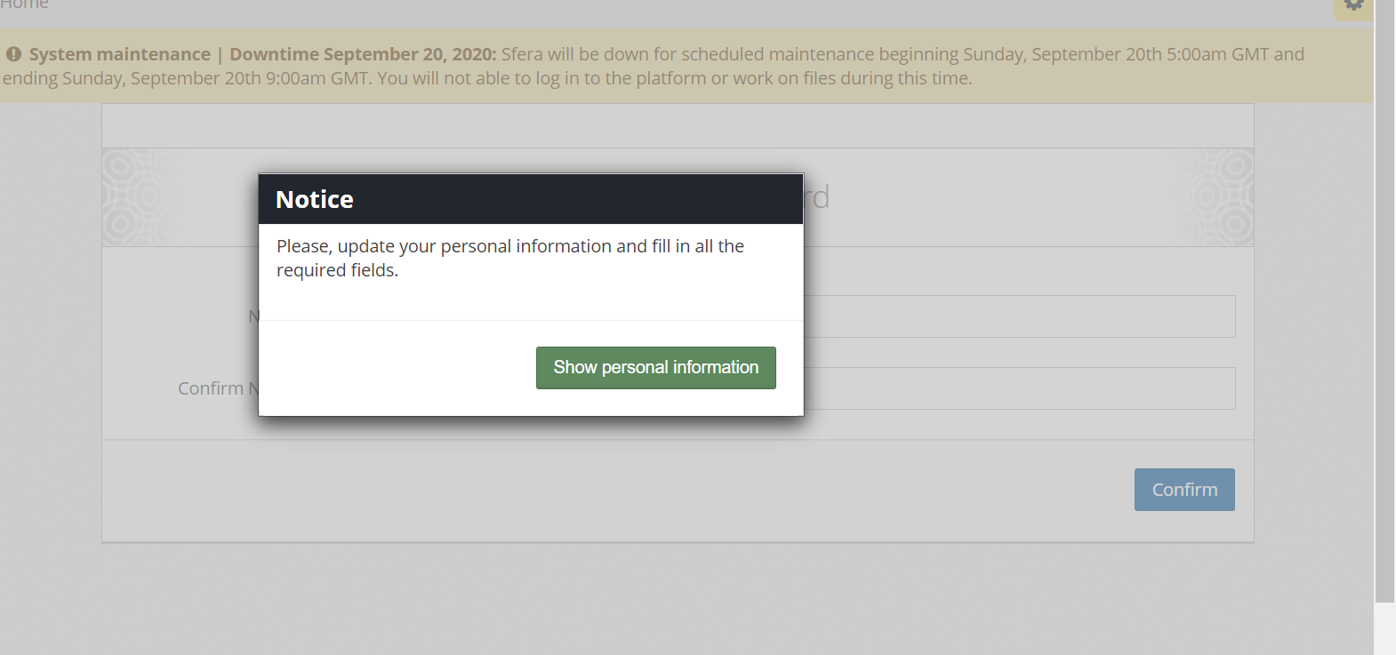

1. Input the Profile information:

Only fill in the required items, and ignore those optional items.

**Note: mobile phone number must be correct.**

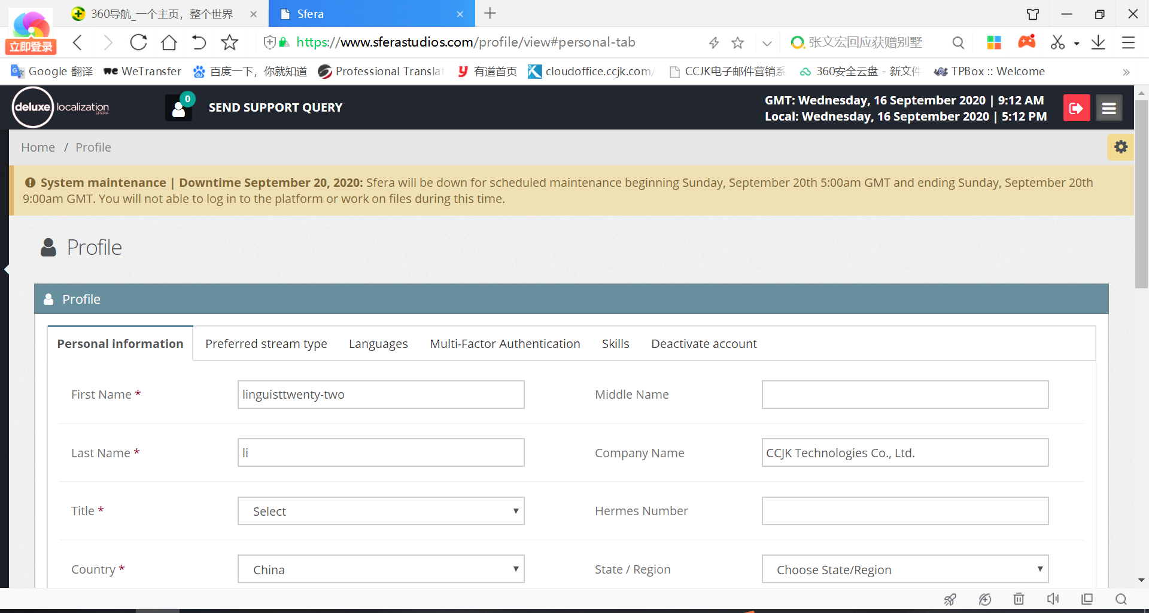

1. After save the profile information, you will see below Notice

Please click “Setup MFA”

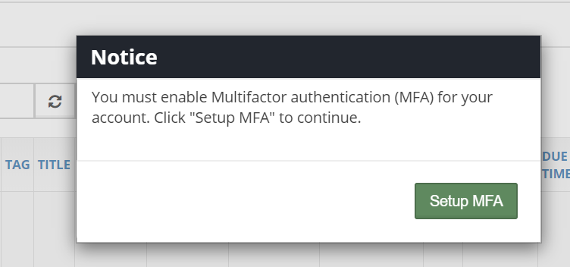

1. Please choose “Use Google Authenticator”.

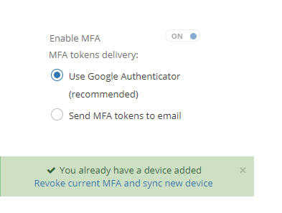

1. Then you need to download the APP in your mobile.

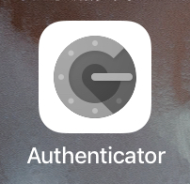

You have two ways to login:

1. As you choosed “Use Google Authenticator”, please click “Manually add account”, you will see your Name and Key. So paste them to your mobile phone to login Authenticator.

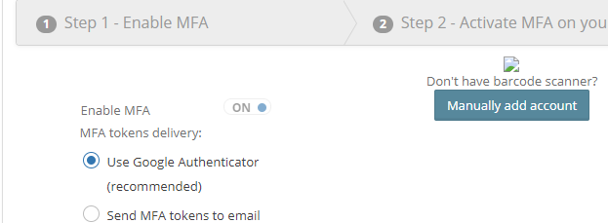

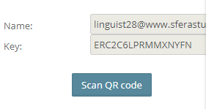

1. You can scan the QR Code to login directly.

